**CSCI 1250 Homework 05 - Honors**

**This homework requires the use of Visual Studio Code (referred to as VS Code) which has been demonstrated in class.**

The purpose of this homework is to move away from the GUI-driven approach to programming that BlueJ implements, and expose you to a more real-world approach to Java programming.

Some aspects of programming that we’ve covered that this assignment will reinforce are **classes**, **objects**, **collections**, and **loops**.

# Setting up the **environment**

* Open File Explorer and make a directory (folder) into which we will be putting our Java files

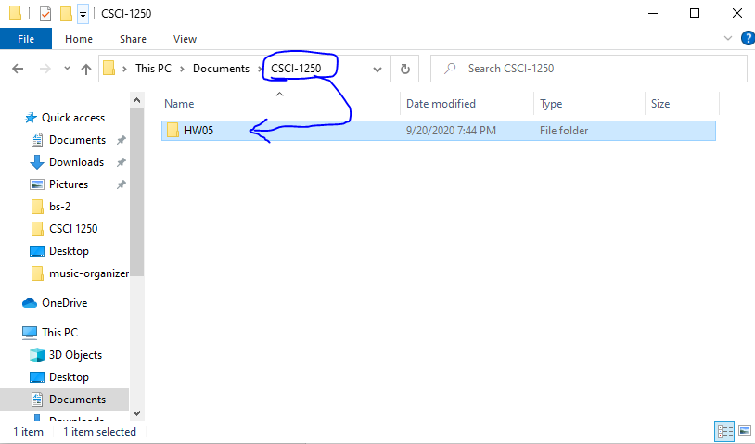

* Open VS Code, choose **File 🡪 Open Folder**, navigate to the folder you made in the previous step, and choose ‘Select Folder’

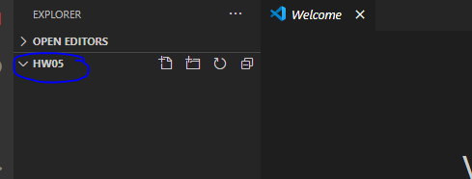

**NOTE**: You do **not** need the ‘Welcome’ tab in VS Code, so feel free to close that tab.

* Click the new file icon, or navigate to **File 🡪 New File**



* Name the new file **Movie.java**

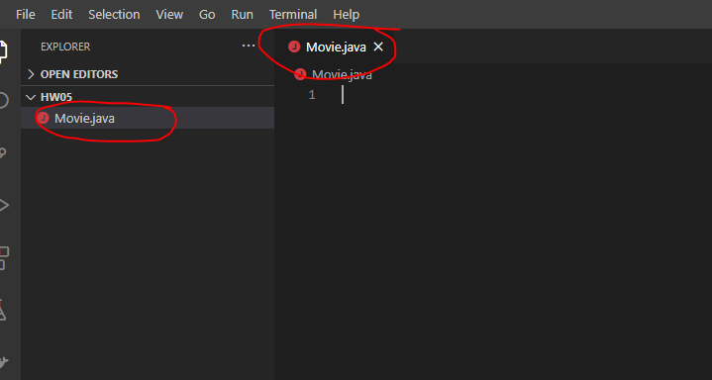

* Click the new file icon, or navigate to **File 🡪 New File**



* Name the new file **Driver.java**

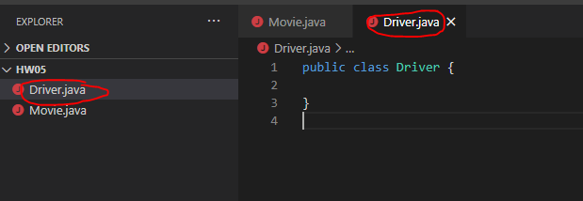

# Assignment requirements

## Movie.java

This class must contain the following.

* Three fields
  + **title** which is a field of the String type
  + **year** which is a field of the integer type
  + **rating** which is a field of the double-precision floating-point type
* A parameterized constructor which sets the value of each field to the value of each parameter
* A method called **printMovie** which will print the details of a movie object to match the following output (doesn’t have to be exact – close enough will be fine)

**===========================**

**Title: Perfect Blue**

**Year: 1997**

**Rating: 8.4**

**===========================**

## Driver.java

This class must contain the following.

* A main method that performs the following functions
  + Instantiate a **collection** of type **Movie** (e.g., ArrayList<Movie>)
  + Instantiate **five** distinct movie objects, each with a different title, year, and rating.
  + Add each movie object to the collection of Movie objects
  + Perform a loop through the collection of Movie objects. Use whatever looping mechanism you prefer. Bonus points will be offered if you choose to use an Iterator for your looping.
    - Regardless of your loop method, call the **printMovie** method with each iteration

## Other Requirements

Your files must abide by the following coding standards. The coding standard document can be found in the Syllabus / Coding standards section of the course materials on D2L.

* File documentation on all files
* Class documentation on all classes
* Method header documentation on all methods
* At least one (1) example of internal documentation (line of code within a method such as a loop header or variable name)

**NOTE**: the above coding standards are referring to commenting. Best practices such as camelCase with your variables and methods are still subject to penalty if not followed.

# Research question

As you noticed in Lab 5, the main method has a parameter that contains **String[] args**. Research the significance of this and why it’s included as part of the main method header.

# Submission

Submit the following in the Homework 5 drop box by the deadline posted in D2L.

* Movie.java
* Driver.java
* Word document containing answer to research question